APPLICATION OF PIT AND FISSURE SEALANTS

DEVELOPED BY

CARLINE PAARMANN, RDH, MEd
Edited & Revised by
Anita Herzog, RDH, MEd

Idaho State Board of Vocational Education
650 West State Street
Boise, Idaho 83720
June 1991

Edited and Revised at
Idaho State University
College of Technology
Workforce Training
Pocatello, Idaho 83209

August 2004

TABLE OF CONTENTS

General Overview of Requirements- - - - - - - - - - - - - - - - - - - - - - - - - - - - - - - - - - - - 3

Introduction - - - - - - - - - - - - - - - - - - - - - - - - - - - - - - - - - - - - - - - - - - - - - - - - - - - 6

Permission Slip- - - - - - - - - - - - - - - - - - - - - - - - - - - - - - - - - - - - - - - - - - - - - - - - - 7

Objectives - - - - - - - - - - - - - - - - - - - - - - - - - - - - - - - - - - - - - - - - - - - - - - - - - - - 9

Background Information - - - - - - - - - - - - - - - - - - - - - - - - - - - - - - - - - - - - - - - - - - -10

Considerations in Patient and Tooth Selection - - - - - - - - - - - - - - - - - - - - - - -11

Acid Etching/Conditioning - - - - - - - - - - - - - - - - - - - - - - - - - - - - - - - - - - - -13

Types of Sealants - - - - - - - - - - - - - - - - - - - - - - - - - - - - - - - - - - - - - - - - - - 14

Instructions to the Patient or Parent - - - - - - - - - - - - - - - - - - - - - - - - - - - - - - 16

Sealant Failure - - - - - - - - - - - - - - - - - - - - - - - - - - - - - - - - - - - - - - - - - - - -17

Placement Procedure - - - - - - - - - - - - - - - - - - - - - - - - - - - - - - - - - - - - - - - - - - - - -18

Study Questions - - - - - - - - - - - - - - - - - - - - - - - - - - - - - - - - - - - - - - - - - - - - - - - - 25

References - - - - - - - - - - - - - - - - - - - - - - - - - - - - - - - - - - - - - - - - - - - - - - - - - - -

Pit and Fissure Evaluation Form - - - - - - - - - - - - - - - - - - - - - - - - - - - - - - - - - - - - -

EXPANDED FUNCTIONS
OF
DENTAL ASSISTING

General Overview of Requirements
For
Application of Pit & Fissure Sealants

APPLICATION OF PIT AND FISSURE SEALANTS

Course Information

Completion Time

Reading/Laboratory/Clinical: Independent study requires that you read the module thoroughly, follow instructions in the modules and those given by your dentist (hygienist) instructor, practice all of the laboratory exercises, and be able to complete the required procedures according to the criteria on each evaluation form. You are encouraged to move quickly through the module. You are also encouraged to complete a review of all infection control procedures and follow through with these procedures as they apply to the modules.

Written Examination: Call the Workforce Training office at (208) 282-3372 to arrange a convenient time to come to the College of Technology to take the test. Bring corrected written answers to the study questions, verifications of practical experiences, and consent forms. A score of 85% is required to pass.

Final Practical examination: Call the Workforce Training office [(208) 282-3372] at the ISU College of Technology to schedule the final practical exam.

Course Description

The primary goal of this course is to provide the dental assistant with background knowledge and clinical experience in applying pit and fissure sealants. Upon successful completion of this course, the student will receive a certificate indicating competency in performing this procedure.

Required Text

Application of Pit and Fissure Sealants, a self-study module developed by Carlene Parrmann, RDH, MEd.; Idaho State University; 1991, Revised by Anita Herzog, RDH, Med, 2004.

Supplemental Text

Robinson, Debi., MS. Ehrlich and Torres Essentials of Dental Assisting, 3rd ed.
Philadelphia: W.B. Saunders Company, 2001.

Course Requirements

- Read the module carefully and practice all procedures.
- Answer all study questions in writing and have the supervising dentist (hygienist) correct them.
3. Place six acceptable sealants on clinical patients:
-three maxillary molars and three mandibular molars on permanent teeth with 100% proficiency.
4. Achieve a minimum of 85% on the written examination.

Materials

Materials and Supplies Presumed Present in a Dental Office

1. Air/water syringe. | 13. Dappen dish with pumice
2. Mouth mirror | 14. Acid etch syringe
3. Explorer | 15. Sealant applicator with dispensing tip
4. Evacuator tip | 16. Bur
5. 2 x 2 gauze squares | 17. Prophy brush
6. Cotton rolls | 18. Patient bib w/ alligator/bib clips
7. Cotton pellets | 19. Slow speed handpiece
8. Forceps/cotton pliers | 20. Prophy head
9. Articulating paper  10. Curing light  11. Dental Floss  12. Sealant materials (self-cure & light-cure) | 21. Cotton roll holder  22. Garmer clamps  23. Rubber dam armamentarium or other isolation materials  24. Fluoride

Evaluation/Grading

This course is designed on a Pass/Fail basis. In order for the student to pass the course, the requirements listed above must be successfully completed. As previously stated, the minimum percentage for acceptable sealants is 100%. A minimum score of 85% must be achieved on the written examination.

Procedure

1. Read the self-study module, Application of Pit and Fissure Sealants.
2. Answer study questions on pages 26 and 27 of this module, have the supervising dentist (hygienist) correct them. (Remember to bring them to the written test along with verification of practical experience, and consent forms.)
3. Complete objectives listed above.
INTRODUCTION

On July 1, 1989, the application of pit and fissure sealants was recognized as a legal procedure for Idaho dental assistants to perform under the direct supervision of a dentist. Assistants must first successfully complete coursework approved by the Idaho State Board of Dentistry. A certificate or diploma of course completion as issued by the teaching institution will be the assistant’s verification of compliance with Board standards. This module was designed to be utilized by Board-approved teaching entities. It offers basic information on the application of pit and fissure sealants which is intended to be supplemented with formal classroom, laboratory and clinical instruction.

The procedure described in this module represents one method for sealant placement. There are several minor variations of this technique, which are dependent upon operator preference and current research.

The exact technique used by the reader in clinical practice will depend, to an extent, upon
individual office philosophy. For example, there are a variety of opinions regarding appropriate etching times and procedures for preparing/cleansing teeth to be sealed. Whichever technique is employed, the reader is advised to refer to the manufacturer’s instructions prior to working with any new material.

To acquire the knowledge and skills necessary to place pit and fissure sealants, the following instructional pattern is suggested:

- Read the module in its entirety and answer the study questions that are
included at the end. Familiarize yourself with the armamentarium that will be needed. Also review the practice activities and evaluation mechanisms that are included.

- Perform all tasks as required at 100% proficiency.

When you have finished all reading, completed the study questions, have the questions corrected, etc., and schedule your written and final practical exams according to the previous directions.

CORONAL POLISHING
PIT AND FISSURE SEALANTS
PERMISSION SLIP

This is to verify that I examined______________________________________________
(patient name)

on_______________and diagnosed the treatment approved below. I give my permission
(date)

for this patient to receive coronal polishing and/or pit and fissure sealants as part of the

Statewide Expanded Functions for Dental Assistants certification program.

□ Coronal polish (check here if hard deposits have been removed and treatment is approved)

□ Pit and Fissure Sealants (check here if teeth were radiographically and
Clinically examined and treatment is approved)
Please list tooth/teeth approved for sealants.

_______ _______
_______ _______
_______ _______
_______ _______
_______ _______
_______ _______

Dentist Signature____________________________

Date______________________________________

According to Idaho State law, the application of pit and fissure sealants and coronal polishing are procedures that must be diagnosed by a dentist. Patients receiving treatment in this program must receive permission from his/her family dentist before the procedure (s) can be performed. Return to the course instructor.
CONSENT FOR TREATMENT

The following services are performed by a dental assistant under the direct supervision of a licensed dentist. The services performed by the dental assistant are required for his/her preparation to become certified in expanded function in the State of Idaho. Prior to treatment, any questions pertaining to these services will be answered by the supervising dentist or the dental hygienist employed in the office.

Place a check by any service(s) which you wish to receive.

_____ Placement and removal of temporary restorations.

_____ Mechanical polishing of restorations.

_____ Monitoring of nitrous oxide. The dental assistant will not initiate
or regulate the flow of nitrous oxide.

_____ Application of pit and fissure sealants.

_____ Coronal polishing. This would be applicable only after examination by a
dentist and removal of calculus by a dentist or dental hygienist.

I have read and understand the preceding paragraph. This Consent for Treatment is hereby fully, freely, and voluntarily executed by me on:

_________ ___________________________(or by:)_________________________
Date Individual Parent or Guardian
(if under 18 years of age)

(Duplicate as necessary)
OBJECTIVES

Following completion of lecture and laboratory/clinical activities, the student will be able to:

- Explain why pits and fissures have a high susceptibility to caries.

- Explain the purpose of pit and fissure sealants.

- Describe types of sealant materials and their relative advantages, disadvantages, and properties.

- Discuss considerations in patient and tooth selection.

- Describe the mechanism by which the sealant attaches to the tooth.

- List conditions that can interfere with bonding of the sealant to the tooth surface.

- List and explain different methods used to maintain a dry field.

- State the precautions that must be taken with regard to the following:
  - selection of a polishing agent
  - use of the air syringe in drying the teeth
  - rinsing the etched tooth surface

- Explain and demonstrate the suggested procedure for application
of various types of pit and fissure sealants.

- Evaluate the results of pit and fissure application.

- Discuss current controversies relevant to sealant placement.

- Describe common errors in the placement of pit and fissure sealants.

- Discuss information that should be relayed to the patient and/or parent regarding sealant placement and subsequent recall appointments.

- Discuss the Idaho Sate Board of Dentistry regulations for Idaho dental assistants with respect to applying pit and fissure sealants.

BACKGROUND INFORMATION

The term pit and fissure sealant is used to describe a resin material that is introduced into the occlusal pit and fissures of caries-susceptible teeth for the purpose of acting as a physical protective barrier against caries-producing bacteria entering the tooth. It has been well documented in the literature that occlusal surfaces in young patients have a high caries susceptibility. The incidence of caries is relatively low on smooth, self-cleansing surfaces (i.e., buccal , lingual, mesial, distal) where fluorides are highly effective in reducing decay. Unfortunately, fluoride is not nearly as effective in the pits and fissures where approximately 50-85% of decay is found. Bacteria are able to breed in deep, narrow faults (fissures) where enamel did not completely form (called noncoalscence of enamel). In many cases toothbrush bristles cannot reach to the depths of these spaces to remove bacteria (see Figure 1).

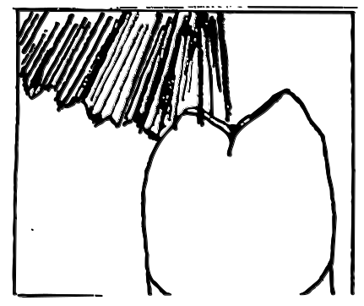

Although the shape and depth of pits and fissures vary considerably even within one tooth, there are three principal types of pit and fissure configurations that have been identified: U type (wider opening), V type (narrower opening), and I type (bottleneck shape). See Figure 2a. The steeper the slope of the inclined planes of the cusps (e.g., deep, narrow pits and fissures such as the I type), the greater the chance that caries exist. Sealant materials are ideal for filling in these defects in tooth anatomy, thus preventing the passage of bacteria, food debris, and nutrients in to these microscopic spaces. (see Figure 2b)

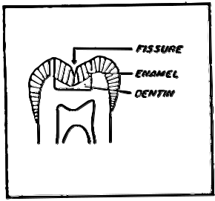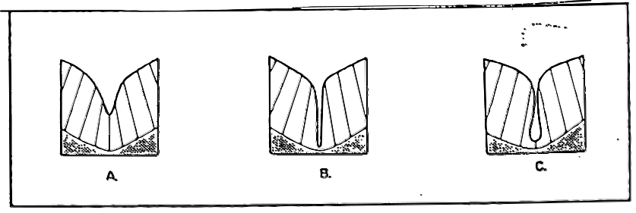

Figure 2a. Occlusal Fissures. Drawings made from microscopic slides showing various in shape and depth of fissures. Tooth on left outlines the section that has been enlarged for A, B, and C. Drawing A: U-type wider opening. Drawing B: V-type narrower opening. Drawing C: I-type opening (bottleneck shape). (Adapted from Wilkins, EM. Clinical Practice of the Dental Hygienist, sixth edition, Lea & Febiger, 1989)

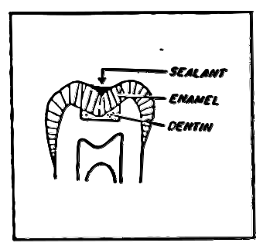
Figure 2b. Pit and Fissure Sealant. Sealant fills
U-type fissure and extends part way up slopes of surrounding cusps. (Adapted from Wilkins, EM. Clinical Practice of the Dental Hygienist, sixth edition, Lea & Febiger, 1989)

Pit and fissure sealants have been found to be 99% effective in prevention of occlusal caries when the material is completely retained. As long as the sealant material remains intact and adheres to the tooth, decay will not develop underneath it. Retention rates (how long the sealant remains intact on the tooth) vary greatly. Studies have shown that retention rates after one year are as high as 90-100%, and then drop to 85% and 65% after three years and seven years respectively.
It has been reported that sealant retention rates are higher on newly erupted teeth rather than mature enamel, on first molars rather than second molars, and on mandibular rather than maxillary teeth. The increased retention in mandibular teeth could be due to the fact that operator access is better on the mandible, maintenance of a dry working area is easier, and gravity assists the sealant in flowing into the fissures. No difference in retention rates between light-cured and self-cured material has been documented. However, the sealant material must form a strong chemical bond with the enamel surface in order for the resin to be retained. Clinical studies show that the majority of sealant failures are due to the operator’s techniques; therefore, sealants are extremely technique sensitive.

CONSIDERATIONS IN PATIENT AND TOOTH SELECTION

Pit and fissure sealants are indicated for selected patients as part of a total preventive program. There are no explicit, foolproof, ideal criteria for selecting individuals or teeth requiring sealants. Children are most susceptible to caries and are usually the age group targeted. Sealants should be placed as soon as possible following eruption to prevent the ignition of the caries process; however, criteria should not be limited to age. The following indications and contraindications are outlined in Robinson, Debi., MS. Ehrlich and Torres Essentials of Dental Assisting, 3rd ed. Philadelphia: W.B. Saunders Company, 2001.

Indications- A sealant is indicated if:
- A deep or irregular fissure, fossa, or pit is present, especially if it catches the tip of the explorer (for example, occlusal pits and fissures, buccal pits of mandibular molar, lingual pits of maxillary incisors).
- The fossa selected for sealant placement is well isolated from another fossa with a restoration present.
- An intact occlusal surface is present where the contra lateral tooth surface is carious or restored.
- If there is no radiographic evidence.

Contraindications- A sealant is contraindicated if:
- Patient behavior does not permit use of adequate dry field (isolation) techniques throughout the procedure.
- There is an open occlusal carious lesion.
- Caries, particularly proximal lesions, exist on other surfaces of the same tooth (radiographs must be current).
- A large occlusal restoration is already present.
- If pits and fissures are well coalesced and self-cleansing.

A sealant is probably indicated if:
- The fossa selected for sealant placement is well isolated from another fossa with a restoration (for example, a maxillary molar with a restoration on the mesial portion of the occlusal surface.)
- The area selected is confined to a fully erupted fossa, even though the distal fossa is impossible to seal due to inadequate eruption.
- An intact occlusal surface is present where the contra-lateral tooth surface (i.e., same tooth surface on the other side of the arch) is carious or restored, as teeth on opposite sides of the mouth are usually equally as prone to caries.
- There is an incipient lesion (early developing caries) in the pit and fissure; this decision would be a matter of professional judgment.

Other Considerations:

Where cost-benefit is critical and priorities must be established, ages 3-4 are most important times for sealing primary molars, ages 6-8 for first permanent molars, and ages 11-13 for second permanent molars. These ages correspond with normal eruption patterns. Sealant should be considered for adults if there is evidence of impending caries susceptibility, for example following excessive intake of sugar, or drug-or radiation-induced xerostomia (abnormal dryness of the mouth). The disease susceptibility of the tooth should be considered, not the age of the individual.

Sealants are applied only after the patient has had an examination and been diagnosed by the dentist. Teeth that do not require restorations may be candidates for sealant placement. If you have any questions about the treatment plan or the tooth surfaces that have been indicated, confirm the diagnosis with the dentist.

ACID ETCHING/CONDITIONING

Sealants must form a strong mechanical bond with the enamel surface in order for the resin to be effectively retained. In its natural state, an enamel surface that has been cleaned but not otherwise treated, will not allow penetration of the sealant resin. Instead, the resin will just spread over the enamel surface. Sealant kits, therefore, are supplied with phosphoric acid etchant, which is applied to the cleansed tooth immediately prior to sealant application. Etching or “conditioning” the tooth with the phosphoric acid for one minute increases the enamel surface area by producing a selective dissolution of the enamel, opening pores into which the resin can flow. Enamel minerals are removed from the surface to a depth of approximately 25 microns. Clinically, the surface appears dull, chalky, and frosted compared with the translucence of normal enamel. A sealant placed over an acid conditioned tooth penetrates into these surface irregularities created by the etchant to form resin “tags” approximately 15-25 microns in length. The tags markedly increase the mechanical retention and are responsible for clinical retention and success of the sealant (see Figure 3). When placing the etchant material, the correct type of hand movement is a gentle dabbing motion.

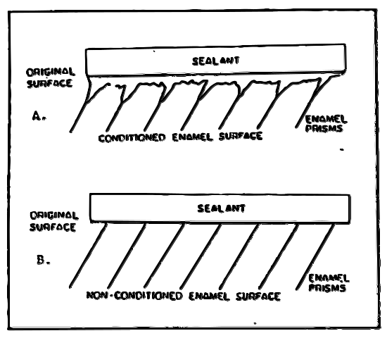
Figure 3. Enamel surface before and after acid etching. Microscopic sealant tags extend into the surface of acid conditioned enamels (A) but do not penetrate the nonconditioned surfaces. Adapted from Preventing Pit and Fissures Caries: A Guide
to Sealant Use. Massachusetts Health Research Institute, Massachusetts Department of Public Health, 1986.

The most critical period in the sealant application is the acid-etch process. If saliva is allowed to contact the etched tooth prior to resin placement, proteins from the saliva will adhere to the etched enamel. Upon contact with saliva, re-mineralization of enamel begins immediately, interfering with penetration of the sealant and significantly reducing bond strength between sealant and enamel. If a conditioned tooth becomes contaminated with saliva prior to resin placement, it should be re-etched for 20-30 seconds. Therefore, the importance of maintaining a dry field through proper isolation of the tooth cannot be overemphasized. The acid etchant should not be allowed to contact the oral soft tissues, skin or eyes at any time. If it does contact any tissue other than enamel, rinse the area with water right away. The solubility rate of etched enamel returns to that of normal enamel after a 24-hour exposure to the saliva.
The tooth must be thoroughly washed (20-30 seconds) and dried following the etching process. If this step is omitted, the presence of microscopic calcium phosphate particles, resulting from the interaction of the phosphoric acid conditioner and the enamel surface, will contaminate the prepared surface. As with saliva contamination, this form of contamination interferes with retention and can affect the clinical outcome of the sealant.

Research regarding the most effective acid concentration and the duration of application time varies considerably. Acid concentrations range from 30-70% phosphoric acid, and application times range from 10-60 seconds. Acid conditioning has been carried out for one minute in most of the published studies. Currently, the most commonly used concentration is 35-37% phosphoric acid with application time between 30-60 seconds. There is no apparent difference in the clinical performance of sealants related to the various phosphoric acid concentrations. However, because of the variability in research findings it is prudent for the clinician to follow the manufacturer’s directions for acid concentration and conditioning time.

TYPES OF SEALANTS

There are numerous brands of sealant materials available from a variety of manufacturers. The most commonly used material is a liquid resin monomer (a plastic) whose base is the reaction product of three parts bisphenol A-glycidyl methacrylate (Bis-GMA) and one part methyl methacrylate (MMA). The MMA is added to decrease viscosity so it can flow into etched enamel to create a good seal. Bis-GMA is the same base material that is used in composite restorations. When used as a restorative material in the placement of tooth-colored restorations, filler particles (e.g. glass, quartz) are added for strength. Sealants usually do not require a great deal of strength since their benefit is in the depth of the pits and fissures. Sealants, therefore, are most commonly of the “unfilled” variety; i.e., the resin does not contain glass filler particles.

The main difference in types of sealant material is in the method of polymerization, or the hardening process. The two methods of polymerization are: 1) chemically-cured (also known as self-cure or autopolymerization); and 2) light-cured (also referred to as photocure, photopolymerization, or photoinitiation). Whatever system is used, finished sealants are essentially the same. Photo polymerization (light cured) may be a more accepted method in today’s dental office. One reason would be better control of the polymerization process. The chemically polymerized sealants are packaged as two-component systems: the liquid catalyst which contains benzoyl peroxide and the liquid base, which is an organic amine. When the peroxide and amine are mixed they react chemically to polymerize in about 60 seconds. The light-cured sealants are packaged as one-paste systems that contain a photoinitiator which is activated by an intense light of specific wavelength. The light is transmitted by a rather expensive hand-held light source (see Figure 4) which affects the polymerization, usually within a 20-second period. The original light-cured resins were initiated with the use of ultraviolet light, but their use has declined with the introduction of the improved visible light-curing units and sealant material. Also available are rechargeable lights about the size of a pen. This newer system is much easier to use because there are no cards and they can be focused easier.

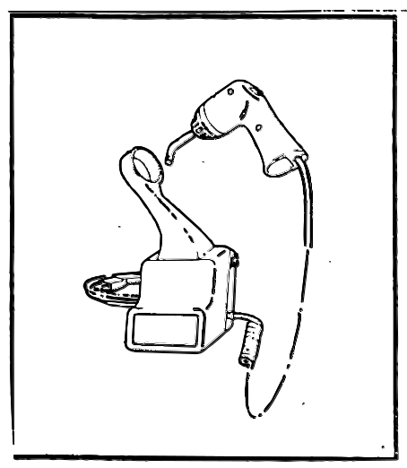

Figure 4. Visible Light Curing Unit. This hand-held light source is designed for polymerizing visible light-cure dental materials, such as pit and fissure sealants. (Taken from 3M Dental Products instruction manual)

Advantages and disadvantages of the chemically-cured and light-cured sealant systems
are outlined below:
Advantages Disadvantages

Self Cure: 1. simple to use 1. once mixing has started,
2. less expensive--does the operator must continue
not require additional mixing and immediately
equipment place the sealant, or stop
and make a new mix if a
problem should occur.
2. the catalyst and base must
be mixed prior to
placement , increasing the
chance of incorporating
air bubbles into final
product.

Light Cure: 1. operator has control over 1. requires extra piece of
the initiation of polymerization equipment that can break
- supplied as single liquid down.
so no mixing is required. 2. high cost of curing light
and shorter shelf life of
material

Sealants are available as clear, white, or opaque. The advantage of the opaque white sealants is the increased visibility which allows for more accurate placement during application as well as visibility during follow-up evaluations. The clear sealants are preferred by many patients because of esthetic reasons. Some clinicians opt for placing opaque sealants in the molar region and clear sealants on the premolars.

INSTRUCTIONS TO THE PATIENT OR PARENT
It is necessary to receive consent from the parent or guardian of a minor or a mentally impaired patient prior to placing a sealant. The patient and/or parent must understand that sealants can only help prevent caries on the tooth surfaces where the sealants are applied; and that plaque control, fluoride therapy, and sugar discipline are still necessary to prevent decay on the rest of the tooth surfaces. Discuss the life expectancy (the retention rate, which varies from patient to patient) of sealants with the patient/guardian. Use a mouth mirror whenever possible to show the patient and/or parent which tooth has been sealed. Explain that it may feel “high” immediately after placement, but that it should feel normal in to three days through normal chewing action. If it does not, the patient should return to the dental office to have the excess height reduced.

The patient or parent should be advised to check the sealant during routine oral hygiene procedures and to contact the dental office if there is any sign of sealant loss or breakage. Inform the patient or parent of the need for six-month recall appointments to monitor sealant retention. At the recall appointment, the sealed tooth should be categorized and treated according to one of the three following categories:

Recall Status of Tooth Treatment

_ _ _ _ _ _ _ _ _ _ _ _ _ _ _ _ _ _ _ _ _ _ _ _ _ _ _ _ _ _ _ _ _ _ _ _ _ _ _ _ _ _ _ _ _ _ _ _
All pits and fissures covered No treatment required
________________________________________________________________________
Sealant missing from some of all of the pits Reseal the exposed
and fissures; exposed surface sound pits and fissures (i.e.,
sealant replaced)
________________________________________________________________________
Sealant missing from some of all of the Restore carious pits
pits and fissures; caries present and fissures (i.e.,
restorative procedures
by the DDS)

SEALANT FAILURE

The success of sealants is dependent upon a strong sealant-to-enamel bond, with sufficient mechanical retention being the primary determinant of clinical success. Improper technique is the major cause of failure or early loss of sealants; therefore, it is imperative that the operator strictly adhere to proper sealant placement. The following list describes common technique errors.

1. Contamination may be caused by either saliva or calcium phosphate products as described earlier. The enamel surface must be re-etched if contaminated.
2. Inadequate surface preparation may be caused by improper cleansing prior to applying the etchant and/or the etching process itself.
3. Incomplete or slow mixing of self-cure sealants affects polymerization of the Bis-GMA material. If polymerization is negatively affected (e.g., starts to set-up before placement), a new mix should be made.
4. Too slow application of the material results in a less viscous (thicker) mix that cannot flow easily into the pits and fissures, causing an incomplete seal. Place material within the time frame recommended by the manufacturer.
5. Air entrapment due to whipping or vigorous mixing can occur during the mixing of self-cured sealants. It is important to replace the caps on the resin bottles since moisture can be lost through evaporation. The result is a less viscous material which does not flow properly.
6. Over-extension of the material beyond the conditioned tooth surface results in a weakened sealant in the areas that are over extended. If the sealant margins extend beyond etched tooth structure, those areas will cause increased micro-leakage beneath the sealant and/or fracture of the sealant. The sealant should be replaced, confining the area of placement to etched tooth structure.
7. Outdated materials may not serve as an effective sealant.

PLACEMENT PROCEDURE

This section of the module will introduce the application of pit and fissure sealants in 10 steps. If these 10 steps are followed correctly, you should have a high success rate in the sealants you apply. The following armamentarium is needed for this procedure:

- Air/water syringe
- Mouth mirror
- Explorer
- Evacuator tip
- 2 x 2 gauze squares
- Cotton rolls
- Cotton pellets
- Forceps/cotton pliers
- Articulating paper
- Curing light
- Dappen dish with pumice
- Acid etch syringe
- Sealant applicator with dispensing tip
- Bur
- Prophy brush
- Patient bib with alligator or bib clips
- Handpiece
- Prophy head
- Cotton roll holder

STEP 1. SELECT APPROPRIATE TEETH
Sealants are not for all caries-free pits and fissures. Teeth should be evaluated in terms of:
- overall caries susceptibility
- existing restorations and carious lesions
- occlusal anatomy

Sealants should be applied to teeth with caries-free occlusal surfaces, to teeth with deep pits and fissures, to teeth with no proximal decay, and to newly-erupted teeth. Sealants should not be applied to teeth in the mouth with rampant interproximal decay, or to teeth with shallow, well-coalesced pits and fissures in a mouth that shows no existing restorations or carious lesions. Sealants are placed only after a thorough examination, including radiographic evaluation, and subsequent diagnosis by the dentist.
Patients who will most often need sealants are children ages 6-13 who exhibit newly-erupted 6-year molars, permanent premolars, or 12-year molars. Partially-erupted teeth may be sealed provided there is no tissue flap over the occlusal surface to interfere with application. Premolars and primary molars may be sealed as well as newly-erupting 3rd molars. It is necessary to receive consent from the parent or guardian of a minor or mentally-impaired patient prior to placing a sealant.

STEP 2. PUMICE OCCLUSAL SURFACE AND RINSE

Flour of pumice applied with a rotary brush works well for cleansing the tooth surface of debris. It is important that there be no oil and no fluoride present in the cleaning agent. Both interfere with the etching process. Therefore, commercial prophy pastes are not recommended for cleansing prior to sealant placement. After polishing the tooth surface to be sealed, rinse the tooth well with water to remove the pumice.

Many operators advocate the use of hydrogen peroxide for the Prophy Jet® (an air-driven polishing system) rather than pumice for optimal plaque removal. Since all three methods will effectively remove plaque if properly performed, the clinician should defer to office policy or personal preference when selecting which method to use. However, Idaho dental assistants currently are not permitted by law to use the Prophy Jet®.

STEP 3. REMOVE PUMICE FROM GROOVES WITH EXPLORER

Pumice particles may become wedged in deep pits and fissures. Check all pits with explorer to be sure any remaining pumice or plaque has been removed. Sometimes it is impossible to remove all the stain from the pits. In this case, you may seal over the stain. Rinse again after removing all plaque and/or pumice. Compressed air may also be of some use.

STEP 4. ISOLATE

There are several ways to isolate the teeth. Rubber dam isolation is ideal but cotton roll isolation is most commonly used. For maximum results, it is suggested that you isolate both maxillary and mandibular quadrants for each sealant application.

Garmer clamps are very effective in maintaining a dry field. With these clamps, a long cotton roll may be placed in the mandibular vestibule and wrapped in a horseshoe-shape fashion to extend to the maxillary vestibule thus isolating the maxillary and mandibular teeth of the same side at the same time. This way the mandibular teeth are sealed first- - then the maxillary teeth, so that an entire side of the mouth is sealed all at once. A garmer clamp also may be used with two short cotton rolls for isolation of the mandibular teeth. The maxillary teeth may then be isolated with either a gauze square or a single cotton roll. Other methods of isolation include the placement of saliva absorbers (for example, Lorvic’s dri-aids®) over the parotid ducts (salivary openings on the inner cheek) next to maxillary molars, or the use of small plastic cotton roll holders. These techniques might be useful in cases where patient management is not a problem or salivary flow is minimal.

Isolation technique is extremely important in the success of the sealant. Saliva contamination of an etched tooth will interfere with sealant retention. If there is difficulty retaining a sealant, a rubber dam should be considered when reapplying the sealant. You may also want to consider the use of bite blocks to keep the patient’s mouth open during the procedure.

STEP 5. DRY AND ETCH

Thoroughly dry the tooth (30 seconds) to prevent dilution of the acid etch solution. Check the air line to make certain it is free of oil prior to drying the tooth because oil and moisture will interfere with sealant bonding. To check the air line, blow air from the air syringe onto the surface of the mouth mirror until there is no trace of oil or moisture.

Apply etchant solution with the acid-etch brush which is packaged with in sealant kit or a cotton pellet. Place the etchant 2/3 up the cuspal slopes using a gentle dabbing motion. A rubbing motion will break the fragile enamel lattice work formed during the etching process. Review the manufacturer’s instructions for proper etching time for the sealant material you are using. Usual etching time for permanent teeth is 60 seconds. If using acid gel, let it set untouched for the recommended time period (usually 60 seconds). Do not allow the etchant to contact the oral mucosa, skin or eyes. If it does, thoroughly rinse the area with water.

The acid should be applied over an area that is 2-3 millimeters beyond the area to be sealed (see Figure 5). It is critical that sealant margins end within the etched enamel area to prevent micro-leakage. If the sealant margin ends on untreated enamel, it will be weak, fracture away easily, or allow bacteria to lodge under the margin. Deciduous teeth should be etched for 1 ½-2 minutes and fluorosed teeth (teeth that have been stained or pitted due to excessive fluoride during formation) should be etched for 15 seconds longer than the regular time.

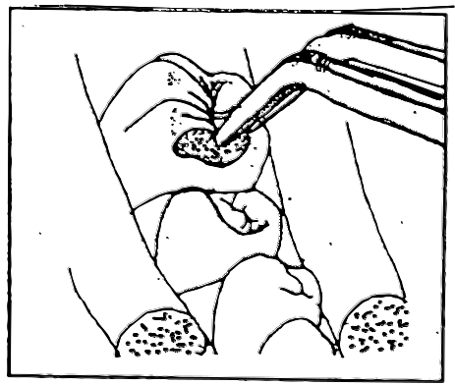

Figure 5. Apply acid etch 2-3 millimeters beyond area to be sealed. In this example, cotton roll isolation is being used to maintain a dry field,
which is critical to the success of
sealant retention.

STEP 6. RINSE 20-30 SECONDS

Suction excess acid from the tooth surface first. Then rinse the tooth with water, holding the evacuator tip close to the tooth to suction remaining acid and water. Rinsing for the full 20-30 seconds is crucial in removing surface by-products of etching which interfere with sealant retention.

STEP 7. RE-ISOLATE

Cotton rolls will become saturated during rinsing so they need to be changed. A second set of loaded Garmer clamps may be used to simplify changing to dry cotton rolls. If this method is used, place a dry cotton roll over the etched surface to prevent saliva contamination during the switch. This is the most vulnerable time for saliva contamination of the etched enamel to occur. If it does occur, re-etch the tooth surface for 30 seconds. Sometimes it is possible to place dry cotton rolls over the saturated ones without changing the saturated cotton rolls. These dry cotton rolls must be held in place.

STEP 8. DRY 20 SECONDS – CHECK ETCHED SURFACE

The tooth must be completely dry before placing the sealant or it will not be retained. Once again, make certain that the air line is not contaminated with oil or water. The etched surface should be a dull, chalky white. If the tooth does not appear frosty white, etch again for 15-30 seconds.

STEP 9. APPLY SEALANT IN 30 SECONDS

Self-cured or Autopolymerized sealants:
Have the sealant ready to dispense quickly. Add 1 drop of catalyst to 1 drop of base. Mix for 5 seconds. You will have 30 seconds to apply the sealant. A brush or a small disposable tube (cannula) as provided by the sealant kit may be used. Immerse the tip of the tube in the sealant mix and release the lever. The applicator will draw up an amount suitable for an occlusal surface (Figure 6)
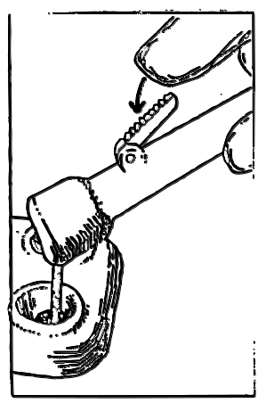

Figure 5. Immerse tip of disposable tube in bottom of
plastic mixing well and release lever to draw resin up
into tip.

Apply sealant in a relatively thick layer extending approximately 2/3 up the cuspal slope. Touch the applicator to a mesial inclined plane, depress lever gradually, and allow it to flow into the fissures toward the dital (see Figure 7). Run the tip of an explorer through the grooves to remove any air bubbles and to assure full coverage. If it appears there is too much material, it may be removed by lightly touching with a cotton tip applicator or cotton pellet. If the sealant is chemically polymerized, it will set up in 1-3 minutes. Check the leftover mixture in the plastic mixing well to see if it is hardened. If so, the tooth may now be checked for polymerization as well. There will always be a greasy film, called the air-inhibited layer, left on the top surface of the sealant. This should be wiped off with a cotton pellet or rinsed off with water.

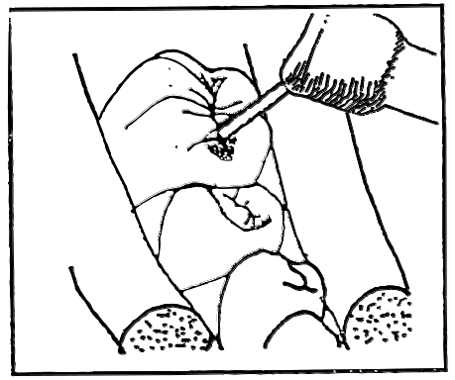

Figure 7. Placing sealant material.

Light-cured or Photopolymerized Sealants:
Dispense 1-2 drops of sealant material into the mixing well that is provided with the sealant kit (2 drops is sufficient quantity for one quadrant). There is no need to mix light-cured sealant. Apply the material in the same manner as explained above for self-cured material with the small disposable tube/applicator.

After the material has been placed, initiate polymerization with the light source. Expose all coated surfaces for 20 seconds, keeping the light guide about 1-2 millimeters from the surface. Touching the light tip to the uncured sealant will coat it with material and prevent accurate light emission. The curing light must expose the entire coated surface; therefore, if the surface to be sealed is larger than the light guide, the light must be moved across the surface, curing each tip-sized area. It is strongly recommended that you use some means of available protective eyewear (special glasses or shields) that filter out the bright light. After the sealant has set, rinse or wipe the occlusal surface (air-inhibited layer).

STEP 10. CHECK APPLICATION WITH EXPLORER

All margins should be checked to make sure that they are flush with the tooth and that application was successful (see Figure 8). Move the tip of the explorer back and forth across the margins and try to “pry” the sealant away from the enamel. If there are any voids or air bubbles, or if complete coverage is not attained, additional sealant can be added without re-etching if a dry field has been maintained. If saliva was allowed to contaminate the surface or the sealant does not adhere, the procedure should be repeated, re-etching for 15-30 seconds. Since all the BIS-GMA products are of the same chemical family, they will easily bond to each other.

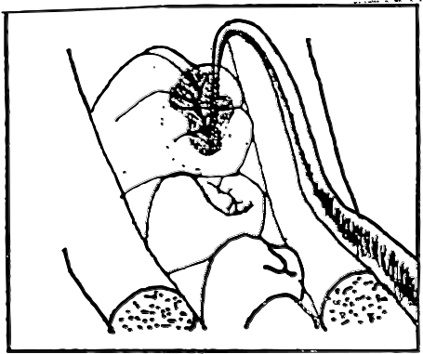

Figure 8. Check all margins with explorer.

Remove the cotton rolls or rubber dam. The gingival 1/3 of the tooth should be checked for excess sealant that may have spilled over during placement. If there is a small excess amount, you may flick it off with an explorer. Contacts should be checked also. Floss on each side of the sealed teeth to make sure contacts were not sealed closed. If they were, remove excess with an explorer.

Occlusion must be checked before dismissing patient. Dry teeth thoroughly and place articulation paper (to check for high spots) on the tooth that has been sealed. Have the patient tap teeth together and slide mandible from side to side. If it is excessively high, there will be heavy dark markings on the sealants which should be polished down using a slow speed handpiece with a finishing bur. If it is just slightly high (smaller dark markings), inform patient that these areas will wear down through natural abrasion in 2-3 days. Apply fluoride to the sealed tooth to cover any etched but unsealed areas of the tooth. Let the patient know that sealants should be checked every 6 months to assure that they have been completely retained. Sealants are charted on the patient’s dental charting and an entry made in the record of services.

A summary of the steps for sealant application follows:

- Select/confirm the appropriate teeth according to the dentist’s diagnosis and criteria for selection.
- Pumice and rinse.
- Remove pumice from grooves with explorer and rinse.
- Isolate teeth to be sealed.
- Dry and etch each tooth for 60 seconds.
- Rinse each tooth for 20-30 seconds.
- Re-isolate the tooth.
- Dry for 20 seconds- check etched surface for an opaque/frost appearance.
- Apply sealant: if using self-cured material, place within 30 seconds of mixing; if using light-cured, place material and expose the entire surface with the curing light for recommended time.
- Check application with explorer and floss for voids or bubbles in sealant.
- Check the occlusion for high spots.
- Apply fluoride to the tooth.
- Give post-operative instructions to the patient.

NOTE: The etching process has dehydrated the tooth, therefore, the tooth is subject to injury and bacteria for approximately 24 hours. Fluoride provides the necessary protection for the tooth during this period of time.

The application of pit and fissure sealants is one of the most valuable preventive procedures that can be provided for patient. They are part of a total preventive program which also includes fluoride, oral hygiene, diet control, and regular checkups. Good oral hygiene is essential to prevent caries on the tooth surfaces where
sealants have not been applied. Sealants should be checked by patients during routine homecare procedures for loss or breakage, and should be replaced when indicated. Recall appointments should be scheduled every six months to monitor sealant retention.

RECORDING/REPORTING
Record the appropriate sealant procedure in the patient’s chart, including date and tooth number. Make note of any difficulties encountered during the procedure and of post-operative instructions given to the patient.
STUDY QUESTIONS
Directions: Answer the following questions on a separate piece of paper to the best of your ability. You may use the module to look up needed information. Upon completion of the questions, review all responses to familiarize yourself with pertinent information.

- What is a pit and fissure sealant?
- What is the purpose of pit and fissure sealants?
- Why are pits and fissures more susceptible to caries than the smooth tooth surfaces?

- Describe the three principle pit and fissure configurations, indicating which type is most susceptible to caries.

- How effective are sealants?
- Retention rates vary greatly and, to some extent, are impacted by the teeth on which they have been placed. Which teeth have high retention rates?

- When are sealants indicated for placement?
- When are sealants contraindicated for placement?
- What factors should be considered for possible sealant placement?
- By what means does the sealant attach to the tooth?
- How does the acid etch increase the bonding ability of the sealant material?
- What are two types of contamination that can interfere with retention and affect the outcome of the sealant?

- What type of acid is most commonly used to etch or condition the tooth prior to sealant placement?

- How long should the acid etch remain on the tooth prior to rinsing?
- Describe the clinical appearance of properly etched enamel.
- What are the initials of the liquid resin that is commonly used as sealant material?
- Are sealants more commonly of the filed variety or the unfilled variety?
- What is the difference between filled and unfilled resin?
- Explain the differences and similarities between light-cured and chemically-cured sealants.

- What are the advantages and disadvantages of the light-cured and chemically-cured sealant systems?

- What instructions should be given to the patient and/or parent regarding pit and fissure sealants?

- Clinical studies show that the majority of the sealant failures are due to the operator’s technique. What are six common technique errors?

- What considerations should be given to selection of a polishing/cleansing agent?
- What methods are effective for establishing a dry field of operation?
- Why is an explorer used in the pits and fissures after the tooth has been polished/cleansed with pumice?

- How and where should the etchant be applied for:
-etchant solution (liquid)?
-etchant gel?

- How should the resin be applied for:
-self-cured sealant?
-for light-cured sealant?

- How should the air-inhibited (non-polymerized) layer be removed?
- If additional sealant resin must be added because of voids or incomplete coverage, how should it be accomplished?

- How is the occlusion checked and adjusted if necessary?

